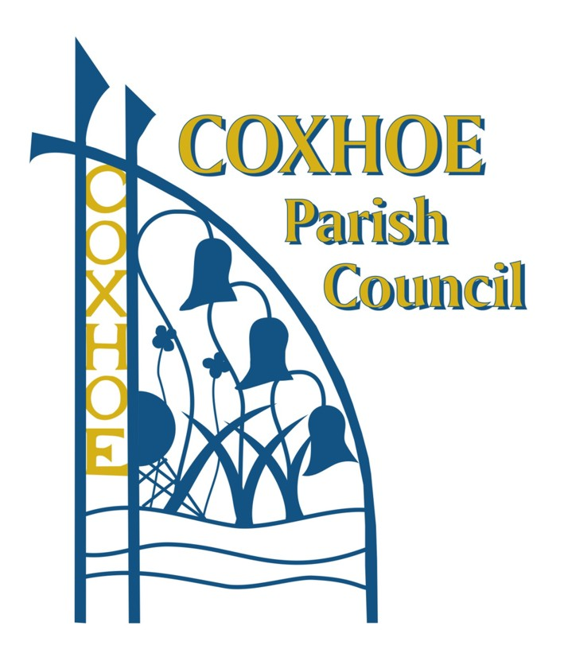
Agen

Coxhoe Parish Council
Communication and Community
Engagement Statement
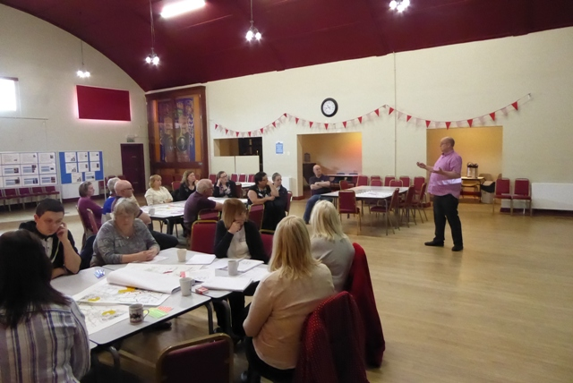
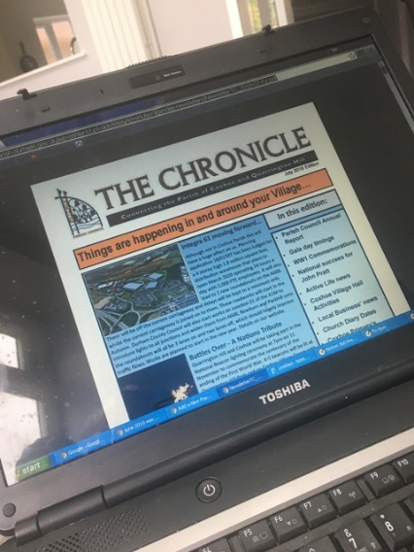
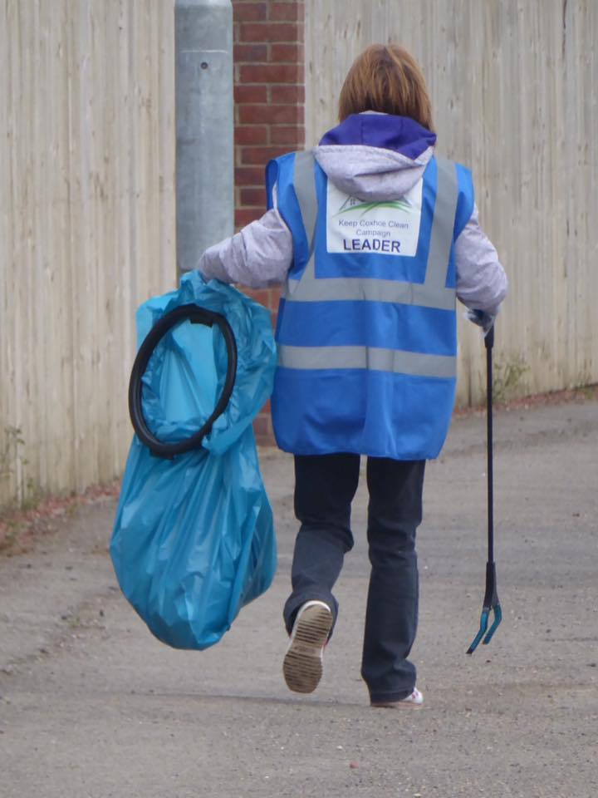

Community Engagement Statement

1. Introduction
Coxhoe Parish Council wants to place the community at the heart of everything it does. The council is committed to high standards of communication and engagement. It wants to ensure that local people have a voice and have every opportunity to be involved in the decisions that affect them and their community. The council encourages residents to be involved in decision making to secure better services and to create a more active and informed community. The council wants to work effectively and co-operatively with partners.
2. Mission, Aims and Objectives
Coxhoe Parish Council aims to be ambitious and aspirational. Its mission is to ‘deliver quality services to Coxhoe and Quarrington Hill’.
The Council is committed to:
- representing and promoting the interests of the area and all its people
- working closely with and listening to residents, businesses and community groups
- engaging with as many people as possible who want to participate in decision-making, monitoring services and planning for the future
- ensuring that local democracy is enhanced by getting closer to the community and being accessible to diverse people and groups in the community
- ensuring that involvement is actively encouraged by using a range of approaches to public involvement and community engagement
- acting with openness and transparency in everything it does
- enabling an active, involved and empowered citizenship through engagement with residents, reaching out to otherwise excluded groups to promote equality of opportunity and in particular seeking the views of young people
- communicating information to the community clearly, timely, factually and appropriately
- improving communication with partners
- being actively involved in various networking organisations and partners
- promoting the image and raising the reputation of the council
- ensuring the resources, training, advice and assistance is available to meet the aims and objectives.

3. Defining the Community
The council considers the community to include:
- residents of Coxhoe and Quarrington Hill
- users of Parish Council services and other services
- Quarrington Hill Community Partnership
- Coxhoe Village Hall Association, Quarrington Hill Community Centre Association and Future Leisure in Coxhoe
- the Head Teacher and Governors of the Primary Schools
- children and young people who live and/or go to school in Coxhoe and Quarrington Hill
- retail and other businesses in the community
- people who appear to have an interest in matters relating to the economic, social and environmental wellbeing of the area
- interest groups, clubs and societies
- voluntary and support organisations
- people who have a common factor such as age, disability, faith, and other groups
- East Durham Rural Corridor Area Action Partnership
- Councillors and staff of Durham County Council
- the Police and other public services such as the NHS
- Councillors, the Parish Clerk and all Parish Council staff and volunteers.
4. Provision of Information to the Community and Opportunities for Community Involvement
Information provided by the Parish Council complies with the Transparency Code and data protection legislation. The council is committed to providing information to the community and providing opportunities for community involvement and appropriate resources for these as follows:
- contact details for the council, individual Councillors, the Council office including public opening hours and the Parish Clerk are made available in the quarterly newsletters, on the noticeboards in each village and on the Council’s website. The quarterly newsletters are aimed at communicating both council and community issues, events and achievements to everyone in our villages
- an answering service for Officers and the website are available 24 hours a day
- two public open sessions will be held by Officers at Coxhoe Village Hall each week, unless cancellation is unavoidable due to annual leave, illness or important commitments for example training courses
- notices of meetings and key council communications are posted on the council’s noticeboards and on the website, and where possible on social media
- notices positively remind members of the community of their entitlement to attend meetings and talk to the council and each meeting and committee meeting will have an agenda item for public participation
- an annual report is published and a summary of this is distributed to every household and business in the villages in the appropriate quarterly newsletter
- the council has signed the Local Charter with Durham County Council in order to improve communication between the councils and improve efficiency of service delivery
- Parish Planning has been and will be carried out with a full commitment to consultation and engagement and will form the basis for planning council priorities
- when undertaking community engagement, the council will make meaningful efforts to reach out to people whose voices may not normally be heard, and make every effort to ensure that a diverse range of views are represented when listening to community feedback and developing services, budgets and business planning for the future
- the council has two way communications with local voluntary organisations; Councillors are members of such organisations in their own right. Coxhoe Village Hall Association, Quarrington Hill Community Centre, Future Leisure in Coxhoe, Coxhoe History Group and Coxhoe Community Watch will be invited to submit reports to the council’s full monthly meetings. This list may be amended or added to by resolution of the full council
- when undertaking consultation and engagement, the council will be mindful that not all people have access to the internet and will consider creative ways to ensure people can have their say and be involved
- councillors will be mindful of opportunities to listen to residents and others and ensure their views are included in council business and activities.

In addition to the above, our website:
- provides details of council services and activities and gives access to a range of documents as well as information about council services
- provides a business directory which local businesses are encouraged to join
- states links to partner services and access to planning applications determined by the county council
- has specific pages aimed at young people; social media (such as but not limited to Facebook) is used to try to communicate and engage with young people
- has dedicated pages for encouraging local democracy and getting people involved in what is happening and what can happen in the villages
- aims to publicise and encourage participation in important meetings that affect residents and businesses, whether or not the meetings are part of council business
- our related social media pages positively address local issues.

5. Opportunities for Formal Representation to the Council
Residents, community organisations and businesses are encouraged to attend meetings and raise issues, concerns and ideas during public participation (see also Public Participation Policy). They are also encouraged to send written representations to the Clerk at least ten days before the date of the next meeting. With agreement of the Clerk, these representations can be included on the agenda for the next meeting and councillors will receive information with the agenda. After formal discussion, the applicant will receive a written response of any decision or action taken by the council.

6. Involvement in Partnerships
The council seeks to work in partnership with other organisations. The council is also actively involved in community organisations and activities and some councillors are trustees for some of these organisations.

7. Role of Councillors and Officers
The council recognises the importance and value of engaging with the local community and the unique perspectives that brings. Councillors and officers will continue to provide a role to encourage and engage the local community in the council’s work through methods set out in this document and in their normal work routine.

8. Specific Areas for Community Involvement
The community will be actively consulted and engaged with on the following:
- Parish Planning: a comprehensive and detailed plan will be developed, implemented and evaluated
- any large scale project the council wishes to undertake.

The council will establish a specific communication and community engagement plan at the start of each process.

9. The Role of Volunteers
The council recognises the importance of the role of volunteers in the delivery of services and the value that is added to council activities by volunteers. The council encourages volunteers to become involved and supports and celebrates their contributions.

